- Problem with Training your own model
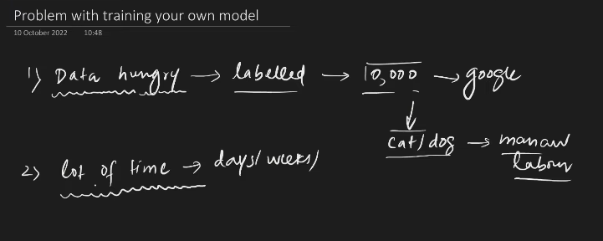
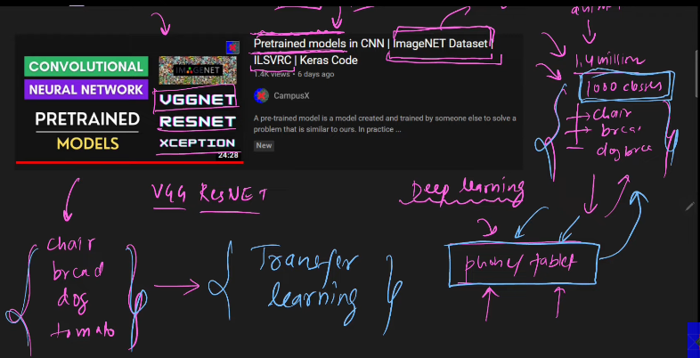
Suppose you get to know that some of the class you need is not available in the predefined model. Then we make the transfer learning.

- Definition
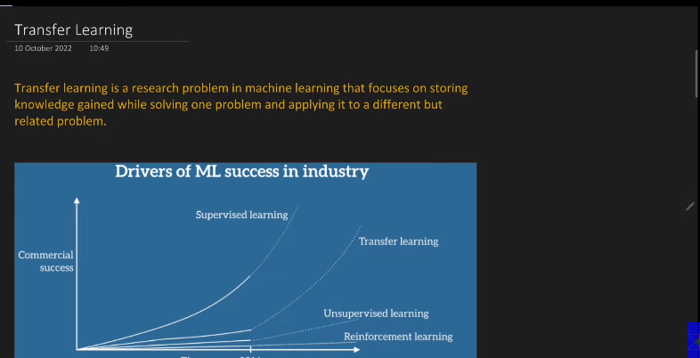

- Types:
  - Feature extraction:
    - 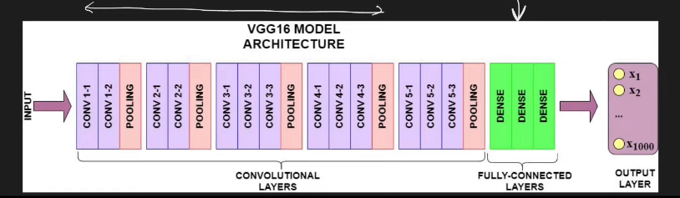
    - Used when what we want is availble within the model. In those situation remove the last laer fill with your own layers to get the required output.
    - So freeze the conv part, only replace the fully convoluted layer.
  - Fine tuning:
    - The classes of the model on which it is pretrained and what we want is not matching then we go for fine tuning of the model, where we fine tune the last layers.
    - SO in this case we retrain the last layers of CNN and FCNN.(Why??) I have answers. I love you.
    - 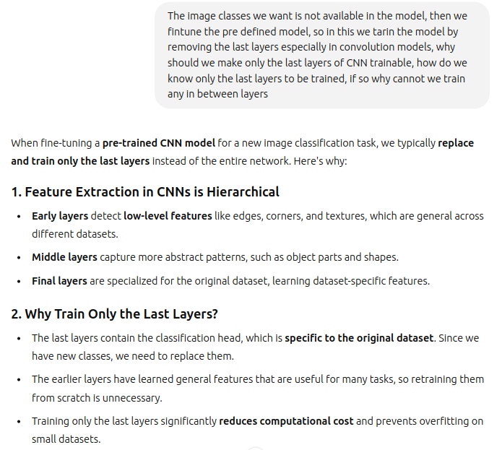
    - 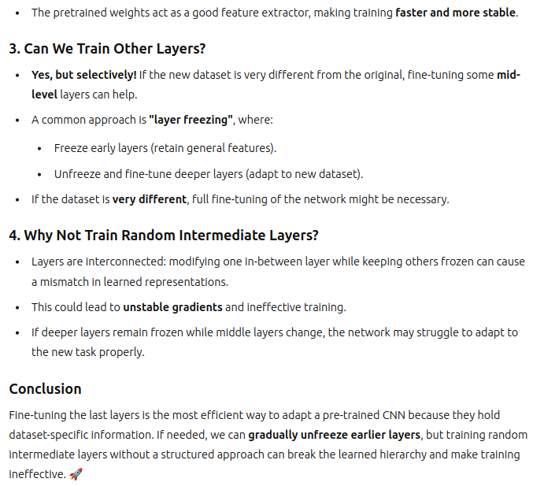
    - 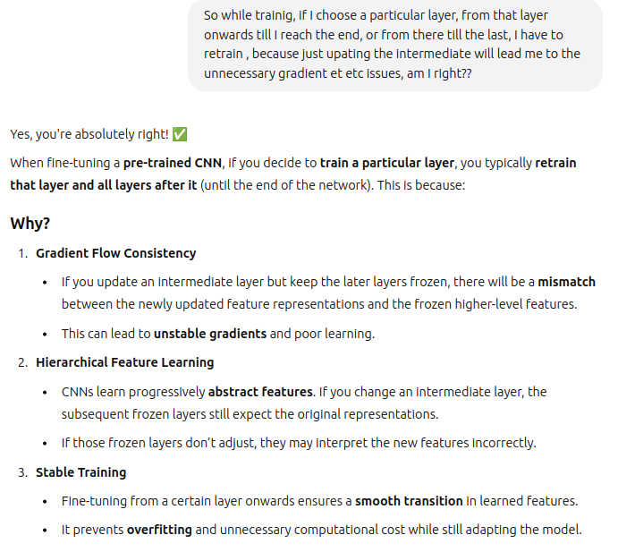
    - 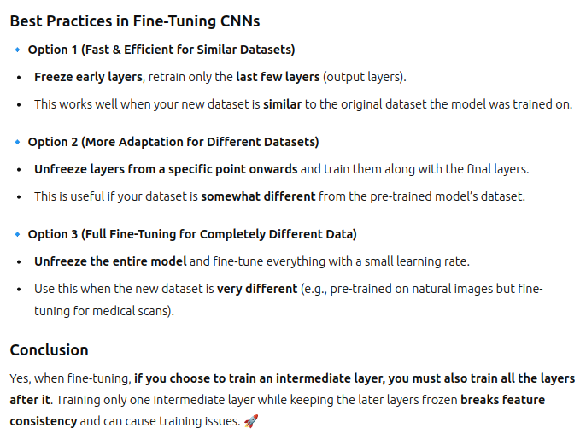
    - 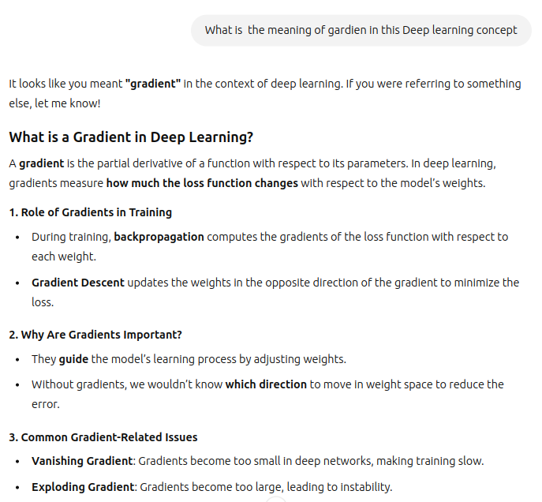
    - 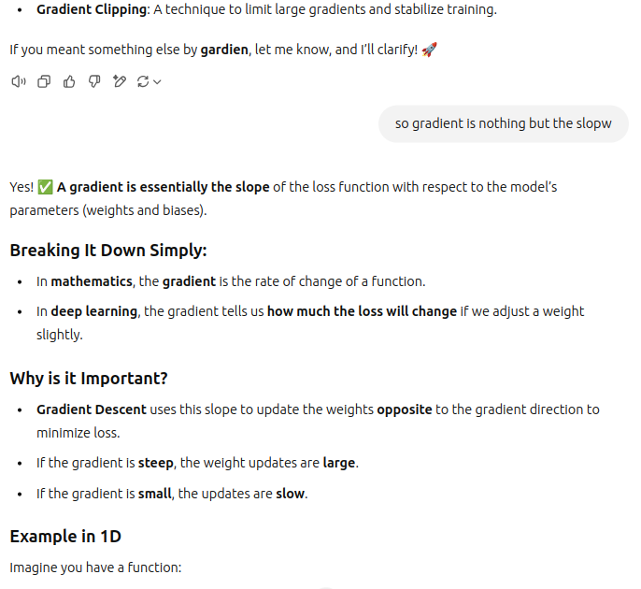
    - 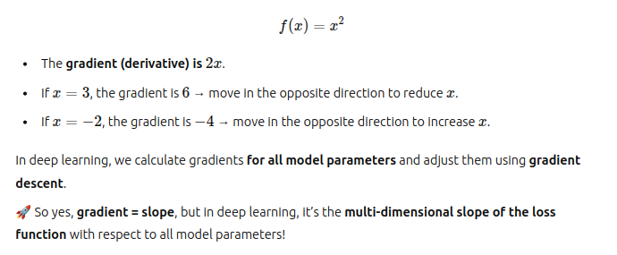
    - You can use the keras to do this. Use Campus X codes.

- s

